These functions not working
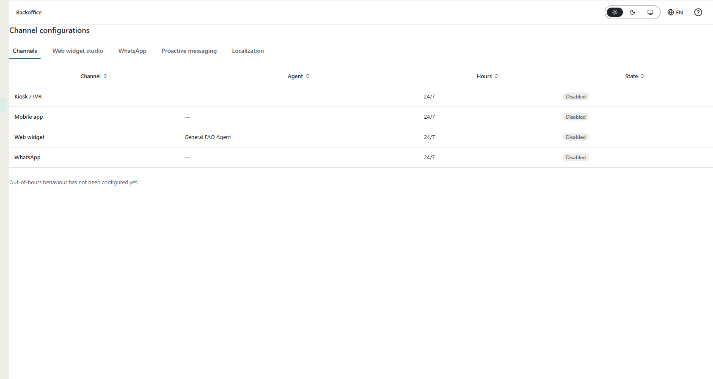
How to configure other channels (kiosk , )
How to enable or disable
Webwedgit not working
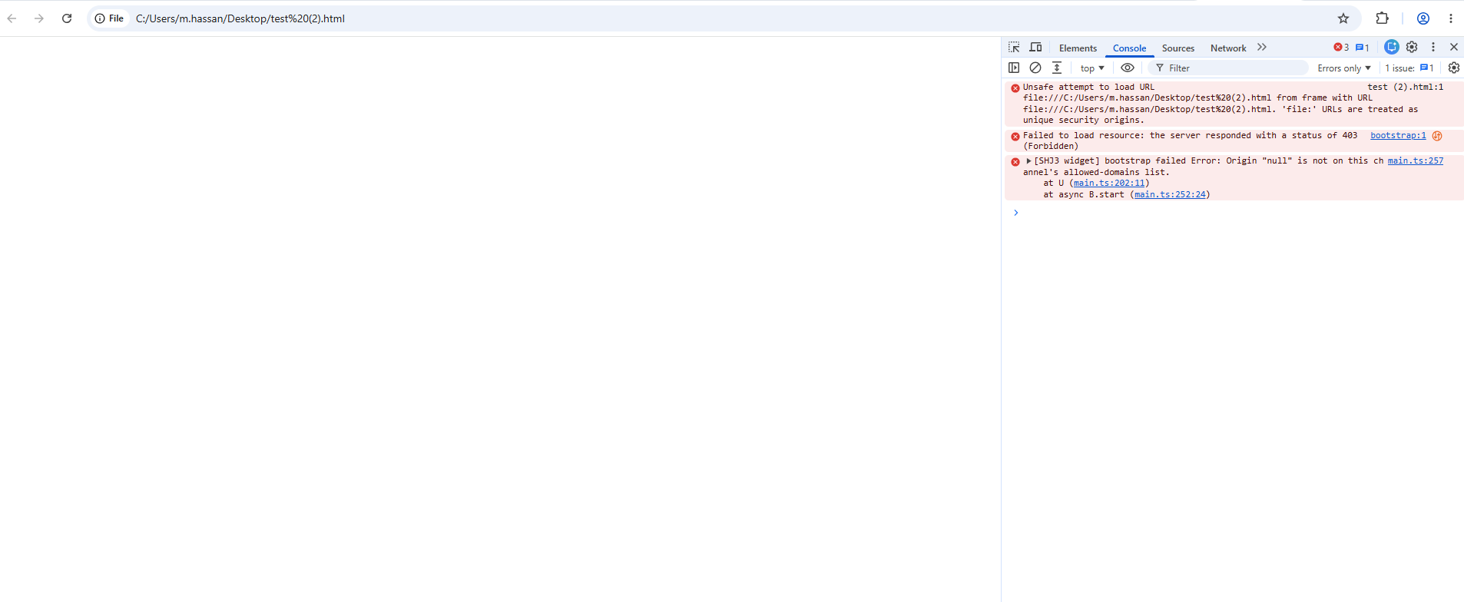 test (2).html:1 Unsafe attempt to load URL file:///C:/Users/m.hassan/Desktop/test%20(2).html from frame with URL file:///C:/Users/m.hassan/Desktop/test%20(2).html. 'file:' URLs are treated as unique security origins.

bootstrap:1 Failed to load resource: the server responded with a status of 403 (Forbidden)
main.ts:257 [SHJ3 widget] bootstrap failed Error: Origin "null" is not on this channel's allowed-domains list.
at U (main.ts:202:11)
at async B.start (main.ts:252:24)
start @ main.ts:257

seed data in the below module
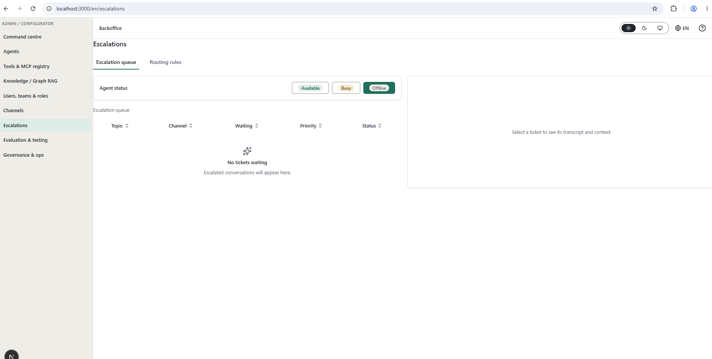
And verify every function

Missing screens
